**SPRINT 4**

DATE - 19 NOVEMBER 2022

TEAM ID - PNT2022TMID24781

PROJECT NAME - SMART SOLUTION FOR RAILWAYS

**PROCEDURE:**

**Step1**: Develop a node red application for GPS.

**Step2** : Develop a python code for GPS.

**Step3**: Run the program.

**Step4**: Train location will be displayed.

**Step5**: Create a node red for wakeup call and E-catering serice.

**NODE RED FLOW:**

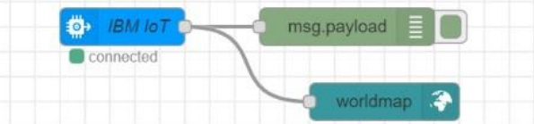

**PYTHON CODE FOR GPS:**

import wiotp.sdk.device

import time import

random myConfig = {

"identity": {

"orgId": "dks66l",

"typeId": "Sudha",

"deviceId":"45"

},

"auth": {

"token": "sudha2002@"

}

}

def myCommandCallback (cmd): print ("Message received from IBM IoT Platform:

%s" % cmd.data['command'])

m=cmd.data['command']

client = wiotp.sdk.device.DeviceClient(config=myConfig, logHandlers=None)

client.connect()

def pub (data):

client.publishEvent(eventId="status", msgFormat="json", data=myData, qos=0, onPublish=None)

print ("Published data Successfully: %s", myData)

while True:

myData={'name': 'Train1', 'lat':13.08363 , 'lon': 80.27080}

pub (myData)

time.sleep (2)

myData={'name': 'Train2', 'lat': 12.40797, 'lon': 79.81410}

pub (myData)

time.sleep (2)

myData={'name': 'Train1', 'lat': 11.83331, 'lon': 79.37465}

pub(myData)

time.sleep(6)

myData={'name': 'Train1', 'lat': 11.59664, 'lon': 78.69899}

pub (myData)

time.sleep (6)

myData={'name': 'Train1', 'lat': 11.63431, 'lon': 78.11122}

pub (myData)

time.sleep (6)

myData={'name': 'Train1', 'lat': 11.32207, 'lon': 77.61684}

pub (myData)

time.sleep (6)

myData={'name': 'Train1', 'lat': 11.03107, 'lon': 76.96864}

pub (myData) time.sleep (6)

client.commandCallback = myCommandCallback

client.disconnect ()

**PYTHON CODE OUTPUT:**

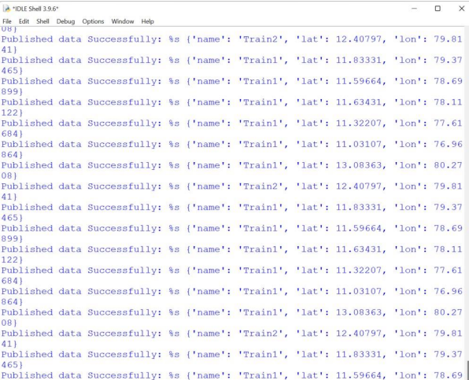

**NODE RED OUTPUT:**

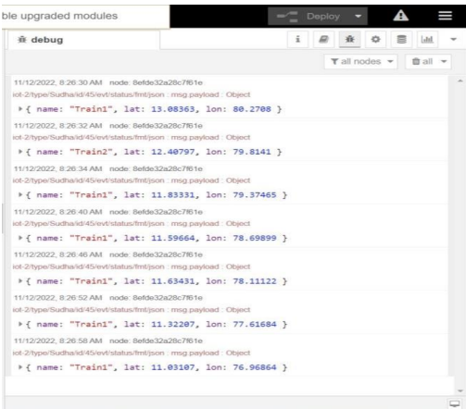

**TRAIN TRACKING :**

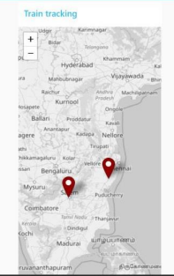

**NODE RED CONNECTION FOR WAKEUP CALL AND E-CATERING SERVICE:**

